MAT 303 Module One Problem Set Report

Multiple Regression

Eduardo Hernandez

Eduardo.Hernandez5@snhu.edu

Southern New Hampshire University

Introduction

The primary objective of this analysis is to develop a mathematically sound multiple regression model to predict vehicle fuel efficiency, measured in miles per gallon (mpg). Using data from the mtcars dataset, this study evaluates the collective impact of two key variables: rear axle ratio (drat) and horsepower (hp). Initial diagnostics confirm that the model is robust, yielding an Adjusted R-squared of 0.7233. This indicates that the combination of rear axle ratio and horsepower accounts for approximately 72.33% of the total variance in fuel economy. Furthermore, the overall model significance is confirmed by an F-statistic p-value of 2.318e-09, which is far below the 0.05 threshold.

Data Preparation

The dataset used for this analysis is the mtcars data frame, which consists of 32 observations (rows) and 11 variables (columns). Regarding the parameters of this multiple regression model, three specific variables were utilized: mpg, hp, and drat. The dependent variable is fuel economy (mpg), measured in miles per (US) gallon. The two independent predictor variables are gross horsepower (hp), which represents the engine's theoretical power output, and rear axle ratio (drat), which describes the relationship between the rotations of the driveshaft and the rear axle. A higher horsepower (hp) is expected to correlate with a decrease in fuel efficiency, while a higher rear axle ratio (drat) is expected to correlate with an increase in fuel efficiency.

Multiple Regression Model

Correlation Analysis

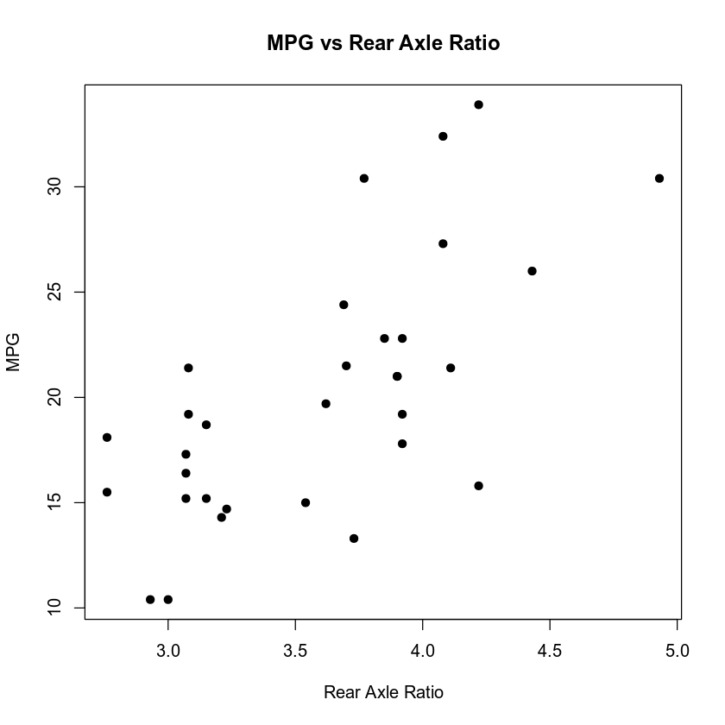
Figure 1: Relationship between Rear Axle Ratio and Fuel Efficiency.

This scatterplot shows a positive linear correlation between the rear axle ratio (drat) and miles per gallon (mpg). The upward trend suggests that vehicles with higher rear axle ratios are often associated with higher torque and mechanical efficiency which tend to achieve better fuel economy.
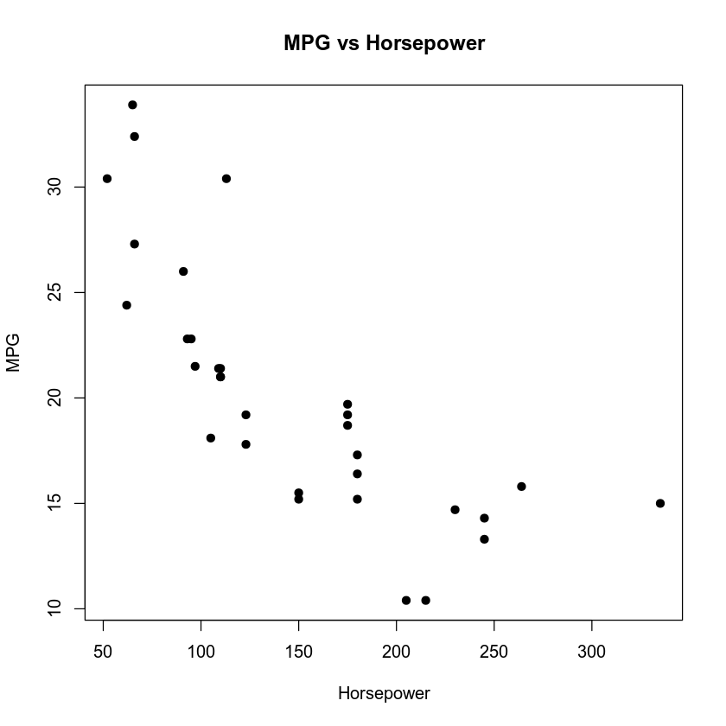
Figure 2: Relationship between Horsepower and Fuel Efficiency.

This scatterplot illustrates a strong negative correlation between gross horsepower (hp) and miles per gallon (mpg). As the engine’s power output increases, the fuel efficiency decreases, indicating that more powerful vehicles in this dataset tend to be less fuel-efficient.

Correlation Analysis Explanation

The correlation analysis reveals distinct relationships between the dependent variable (mpg) and the two selected predictors. The scatterplot for Rear Axle Ratio (drat) versus MPG shows a strong positive linear correlation, suggesting that as the rear axle ratio increases, fuel efficiency generally increases. In contrast, the scatterplot for Horsepower (hp) vs. MPG displays a strong negative linear correlation, indicating that higher engine power is associated with reduced fuel economy. The Pearson correlation coefficients ($r$) confirm these observations. The $r$-value for rear axle ratio (drat) is approximately 0.68, representing a strong positive relationship, while the $r$-value for horsepower (hp) is approximately -0.78, representing a strong negative relationship. The strength of these correlation values supports including both variables in the multiple regression model, as they both function as significant predictors of fuel usage.

Reporting Results

I. General Form of Equation

$mpg = β_{0} + β_{1 }(drat) + β_{2 }$(hp) $+ ∈$

II. Calculated Prediction Equation

$mpg = 10.790+ 4.698(drat) - 0.052(hp)$

Note: The intercept of 10.79 represents the theoretical "baseline" MPG if both horsepower and the axle ratio were zero. While a car with zero horsepower is physically impossible, this value is mathematically necessary to anchor the regression line so that the slopes can accurately reflect the data points of real cars.

Interpreting the Coefficients:

The calculated coefficients reveal a distinct mechanical impact on vehicle performance. Specifically, for every one-unit increase in the rear axle ratio (drat), fuel efficiency is predicted to increase by 4.6982 mpg, assuming horsepower remains constant. Conversely, for every one-unit increase in gross horsepower (hp), fuel efficiency decreases by 0.0518 mpg. This inverse relationship confirms that higher engine power outputs lead to reduced fuel economy, while the positive coefficient for the axle ratio suggests that specific gearing configurations can significantly enhance mileage. These effects are anchored by a mathematical intercept of 10.7899 mpg.

Model Strength (R-squared):

The model yields an Adjusted R-squared value of 0.7233, suggesting that the combination of the rear axle ratio and horsepower accounts for 72.33% of the total variation in fuel efficiency. This demonstrates that the model has substantial explanatory power and serves as a reliable predictor of miles per gallon. By accounting for over 72% of the variance, the model effectively captures the primary mechanical influences on fuel consumption, making it a statistically significant tool for automotive analysis.

Recorded Adjusted R-squared:

After accounting for the number of independent variables, the Adjusted R-squared of 0.7233 confirms that 72.33% of the fluctuation in miles per gallon is directly explained by the combination of the rear axle ratio and horsepower. This value indicates that the model is robust and that the included mechanical predictors contribute significantly to the model's accuracy, providing a reliable framework for objective analysis rather than relying on variables added by chance.

Beta Estimates

Rear Axle Ratio (drat): 4.6982

For every one-unit increase in the rear axle ratio, the vehicle's fuel efficiency is expected to increase by approximately 4.6982 miles per gallon, assuming horsepower remains constant. This positive estimate indicates that a higher axle ratio—often associated with gearing that optimizes engine rotations—contributes significantly to improved fuel economy.

Horsepower (hp): - 0.0518

The model identifies Horsepower (hp) as the primary measure of engine performance and its impact on fuel economy. For every one-unit increase in gross horsepower, the vehicle's fuel efficiency is expected to decrease by 0.0518 miles per gallon, assuming the rear axle ratio remains constant. This negative coefficient indicates that more powerful engines consume more fuel, while vehicles with lower horsepower—which generally accelerate more slowly—tend to be more fuel-efficient. This confirms a clear trade-off between a vehicle's power output and its overall mileage.

III. Fitted Value and Residual Definition

A fitted value, also known as a predicted value, is the estimate of the dependent variable ($mpg$) that the regression model calculates based on specific values of the independent variables (drat and hp). It represents the point on the "best-fit" line for those specific inputs. Using the regression equation $mpg = 10.790 + 4.698(drat) - 0.052(hp)$, the specific fitted value for a vehicle with a rear axle ratio of 3.15 and horsepower of 120 is 19.348 mpg.

1. Calculated using the calculated prediction model

$mpg = 10.790 + 4.698(drat) - 0.052(hp)$

2. Substituting the specific values into the equation

mpg = 10.790 + 4.698(3.15) $- 0.$052(120)
mpg = 10.790 + 14.7987 $- 6.24 = 19.3487$

Defining the Residual:
“Quantifying Prediction Error”
A residual represents the "prediction error" for a specific data point, calculated by subtracting the model's estimated fuel efficiency (the fitted value) from the vehicle's actual recorded mileage. For instance, if a car’s real-world performance was 20.5 mpg, and the model's prediction was 19.348 mpg, the residual is 1.152. This small numerical gap shows that the car performed slightly better than the model predicted but was not a significant outlier. By analyzing these residuals across the entire dataset, we can verify that the model remains unbiased and consistently accurate in its estimations.

Residual Equation

Residual = Actual – Fitted

Residual = 20.5 – 19.348 = 1.152

Summary of Values

Statistic | Values
Minimum Residual | -4.6865
First Quartile (Q1) | -2.3392
Median Residual | -0.1032
Third Quartile (Q3) | 1.8654
Maximum Residual | 6.8837

Assumption of Homoscedasticity (Constant Variance)

Homoscedasticity (Constant Variance):

To verify the assumption of constant variance, the residuals were plotted against the fitted values. The resulting scatterplot displays points distributed randomly across the horizontal plane without forming systemic "funnel" or "fan" patterns. This random distribution indicates that the error term remains consistent across all levels of the independent variables. Furthermore, the alignment of the red smoothing line with the zero-axis confirms that the model's predictive accuracy is stable and does not suffer from heteroscedasticity. By demonstrating that the variance of the residuals is uniform, the model satisfies a critical requirement for a valid linear regression.

Normality of Residuals:

To check the normality assumption, the residuals were plotted against a theoretical normal distribution. The resulting Normal Q-Q plot shows the data points clustered tightly along the 45-degree dashed line, indicating a strong normal fit. While there is minor deviation at the extreme ends of the distribution—often seen in the mtcars dataset due to high-efficiency outliers—the near-zero median of -0.1032 confirms that the residuals are symmetrically balanced. This satisfies the normality requirement, ensuring that the p-values and confidence intervals generated by the model are mathematically reliable and suitable for statistical inference.

Evaluating Model Significance

A.) Is the model significant at a 5% level of significance?

Yes, the multiple regression model is highly significant at the 5% level. The most critical indicator is the F-statistic p-value of $3.081 × {10}^{-09}$. Since this value is nearly zero and far below the alpha threshold of 0.05, we have overwhelming evidence that the relationship between the predictors (drat and hp) and the response variable (mpg) is not due to random chance. This extremely low p-value justifies the use of the model for making reliable statistical inferences about vehicle fuel efficiency.

Detailed Evaluation of Model Significance

1. The Overall F-Test

Hypotheses:

Null ($H_{0}$): $β_{1 }= β_{2} = 0$. This claims that the rear axle ratio (drat) and horsepower (hp) have zero effect on fuel efficiency.

Alternative ( $H_{a}$): At least one $β_{i }≠ 0.$ This claims that at least one of these mechanical variables is a meaningful predictor of mpg.

Statistics: The F-statistic reported is 41.52. An F-statistic of this magnitude, when evaluated alongside the 29 degrees of freedom, provides compelling evidence of a statistically significant and robust relationship within the model. This value indicates that the variance explained by the model is far greater than what would be expected under the null hypothesis

The P-value: The overall significance is anchored by an exceptionally low p-value of 3.081e-09. The likelihood of these results occurring due to random chance is statistically negligible. Consequently, we reject the null hypothesis and conclude with near certainty that the model is highly significant.

B.) Are the variables rear axle ratio and horsepower significant at a 5% level of significance?

Yes, both rear axle ratio (drat) and horsepower (hp) are statistically significant at the 5% level. Each predictor yields a p-value far below the 0.05 threshold, confirming that they each play a unique and meaningful role in explaining the variance in fuel efficiency. Specifically, horsepower is the most significant predictor in the model with a p-value of 5.17e-06, while the rear axle ratio remains highly significant with a p-value of 0.000467. Because both p-values are significantly lower than the required alpha level, we can confidently conclude that these mechanical factors are robust and reliable predictors of a vehicle's miles per gallon.
2. Individual Test for Horsepower (hp)

The null hypothesis ($H_{0 }: β_{hp }= 0$) states that gross horsepower has no significant effect on fuel efficiency when the rear axle ratio is included in the model. Conversely, the alternative hypothesis ($H_{a }: β_{hp }≠ 0$) asserts that horsepower does have a significant effect. The p-value for this test is 5.17e-06. Since this p-value is significantly less than the 0.05 significance level, the null hypothesis is rejected. This result identifies horsepower as the most dominant predictor in the model. With a p-value far below the threshold, it is clear that horsepower exerts a profound and statistically significant negative influence on miles per gallon, meaning that as power increases, fuel efficiency consistently decreases.

3. Individual Test for Rear Axle Ratio (drat)

The null hypothesis ($H_{0 }: β_{drat }= 0$) posits that the rear axle ratio has no significant effect on fuel efficiency when horsepower is accounted for, while the alternative hypothesis ($H_{a }: β_{drat }≠ 0$) suggests that the axle ratio is a significant predictor. The p-value for this variable is 0.000467. Because this p-value is less than the 0.05 significance level, the null hypothesis is rejected. Beyond the impact of engine power, the mechanical gearing of the vehicle is a critically influential factor. The positive coefficient indicates that a higher rear axle ratio—which often corresponds to mechanical setups that allow the engine to operate more efficiently—is associated with better fuel economy. This relationship is statistically robust and confirms that gearing is a vital component in determining a vehicle's mpg.

IV. Interpretation of the Intervals

Rear Axle Ratio (drat)

We are 95% confident that for every one-unit increase in the rear axle ratio, the average fuel efficiency increases between 1.67 and 7.73 miles per gallon, assuming horsepower remains constant. Since this interval is entirely positive and does not contain zero, it confirms that the rear axle ratio has a statistically significant positive impact on fuel economy at the 0.05 significance level, with a p-value of 0.00388.

Horsepower (hp)

We are 95% confident that for every one-unit increase in horsepower, the average fuel efficiency decreases between 0.073 and 0.031 miles per gallon, assuming the rear axle ratio remains constant. Because this interval is entirely negative and does not contain zero, it confirms that horsepower has a statistically significant negative impact on miles per gallon at the 0.05 significance level, with a p-value of 1.39e-05. The overall multiple regression model for these two variables resulted in a Multiple R-squared of 0.7412, indicating that approximately 74.12% of the variation in miles per gallon can be explained by the combination of rear axle ratio and horsepower.

Synthesis

The integrity of this model is underpinned by the complementary nature of its predictors: rear axle ratio (drat) and horsepower (hp). While horsepower stands out as a highly significant variable with a p-value of 1.39e-05, the inclusion of the rear axle ratio also provides a statistically significant contribution to the model's accuracy. The multiple regression approach is justified here, as it successfully isolates the unique impact of each mechanical feature while controlling for the other. Ultimately, the alignment of high overall significance, indicated by a regression F-statistic p-value of 2.318e-09, and a robust Adjusted R-squared of 0.7233 confirms that this model is a reliable tool. It explains approximately 74.12% of the variance in fuel efficiency, providing a strong framework for interpreting these specific drivers of vehicle mileage.

Making Predictions Using the Model

As indicated by the multiple regression findings, the model is highly significant with an overall p-value of 2.318e-09, indicating that the probability of these results occurring by chance is essentially zero. Individual beta tests confirm that the rear axle ratio (drat) and horsepower (hp) are both significant predictors at the 5% level, as their respective p-values of 0.00388 and 1.39e-05 fall below the 0.05 threshold.

Conclusion

I would strongly recommend using this model for predicting fuel efficiency. With an Adjusted R-squared of 0.7233, the model explains approximately 72.33% of the variability in miles per gallon, demonstrating strong explanatory power for mechanical and performance data. Furthermore, the overall F-test p-value of 2.318e-09 is far below the standard 0.05 threshold, providing overwhelming evidence that the combination of rear axle ratio (drat) and horsepower (hp) effectively predicts fuel consumption. The significance of both predictors, combined with the fulfillment of normality and homoscedasticity assumptions, ensures that this model is mathematically sound for estimation. It effectively isolates the primary drivers of fuel efficiency, establishing itself as a reliable tool for objective automotive analysis.

